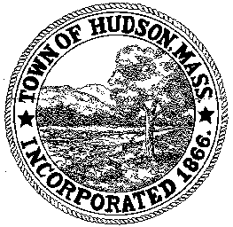

CONSERVATION COMMISSION
78 Main Street, Hudson, MA 01749
(978) 562-2020

Leif Longtine, Chairman David Esteves, Vice Chairman Paul Byrne, Member

Terrence Joyce, Member Joseph Rodrigues, Member W. Minot Wood, Member

Meeting Agenda
May 2, 2013
7:00 P.M.

- Preliminaries
  - Open Meeting
  - Roll Call

2.0 New Business
2.1 RDA 444
Applicant: Lawrence Sherman
Location: 6 Lower Road
Project Description: Construction of a single family home on vacant lot, within 100’ of intermittent brook.

2.2 RDA 445
Applicant: Stella Realty Partners Hudson, LLC
Location: 34 Tower Street
Project Description: Resurface the existing paved parking lot, remove vegetation within the 100’ buffer zone.

2.3 DEP 190-0562 Amendment to the Order of Conditions
Applicant: Calebe DeCastro
Location: 80 River Street
Project: install a 6’ chain link fence on property between 78 and 80 River Street and along the back of the property.

2.3 Marianne Neuman

2.4 Community Garden request

2.5 Request for Review and Comments – Cabot Ridge Apartments

2.5 Signs 25 Washington Street

2.6 Minutes – April 18, 2013

3.0 Adjournment

